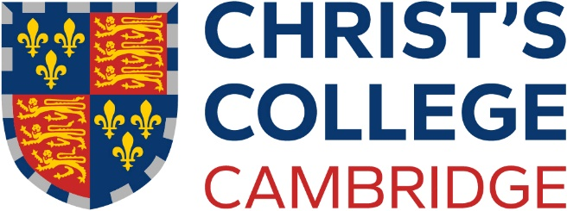

Non-Stipendiary Junior Research Fellowship

Further Particulars

Christ’s College, Cambridge invites applications for a non-stipendiary Junior Research Fellowship in Physical Sciences, Technology, Arts, Humanities, or Social Sciences. The Fellowship is only open to those who have already secured, or who expect to secure, postdoctoral funding support at the University of Cambridge. It will be tenable for at least two years, but not more than four years, from no later than 1 October 2025, and is not renewable.

A Junior Research Fellowship is intended for a researcher early in their career and offers an opportunity to carry out novel research in a stimulating academic environment. The successful candidate is expected to be either a postgraduate student, probably in the latter stages of research leading to a PhD degree (or equivalent), or a postdoctoral researcher who has completed their PhD degree after 1 January 2023. Candidates who do not fulfil these criteria are unlikely to be considered.

Tenure of the Fellowship is conditional upon the holder devoting themselves to research to the satisfaction of the College Council, and upon the holder continuing to have postdoctoral support at the University. The holder is expected to carry out their research within the University of Cambridge, but the tenure may be split by a period, or periods, of intermission not exceeding a total of two years in duration, to enable the holder to pursue research away from Cambridge.

In addition to pursuing research, it is hoped that the Research Fellow will take a full part in College life and activities. When appropriate they are encouraged to undertake some undergraduate teaching during term, for which payment will be made at normal supervision rates. The Research Fellow will be a member of the Governing Body, eligible to sit on College committees, with the full privileges of a Fellow of the College including seven free meals per week, the possibility of financial support for expenses associated with their research, use of a study room or, where appropriate, single accommodation in College.

Applicants must download the non-stipendiary JRF application form available from the Christ’s College website at https://www.christs.cam.ac.uk/vacancies-christs-college and should submit the completed form together with a letter of application to jrf@christs.cam.ac.uk so as to arrive no later than 12 noon on Wednesday 4 December 2024. Applicants must also select two persons to act as academic referees and provide their contact details in the relevant section of the form. Applicants are themselves responsible for ensuring that their chosen referees send their references direct to jrf@christs.cam.ac.uk by the same closing date of 12 noon on Wednesday 4 December 2024 in order for the application to be eligible.

It may not be necessary for the referees to write new references; submitting a copy of a reference already sent in connection with the applicant’s postdoctoral appointment will often suffice, and this is entirely acceptable to the College even if the reference has not been rewritten to match the requirements of this Fellowship.

Shortlisted candidates may be invited for interview, expected to be held on or around Tuesday 14 January 2025. Further details of the Fellowship competition are provided on the website: https://www.christs.cam.ac.uk/vacancies-christs-college.

Christ’s College is committed to protecting your personal information and being transparent about the information we hold. Our data protection policy and statements can be viewed on our website: https://www.christs.cam.ac.uk/college-administrative-information-and-policy- documents

