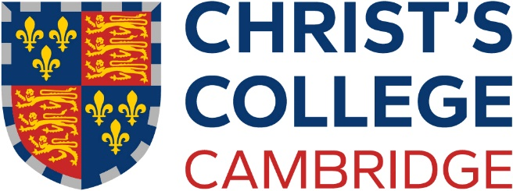

Stipendiary Junior Research Fellowship

Further Particulars

Christ’s College, Cambridge invites applications for a stipendiary Junior Research Fellowship in specified areas of the Arts, Humanities and Social Sciences. It will be tenable for four years from no later than 1 October 2025 and is not renewable.

A Junior Research Fellowship is intended for a researcher early in their career and, in this case, is restricted to applicants in one or more of the following subject areas: Anthropology; Archaeology; Asian and Middle Eastern Studies; English (limited to literature of 1800 to the present day); Law; Linguistics; Modern and Medieval Languages; Philosophy (excluding Philosophy of Science).

A Junior Research Fellowship offers an opportunity to carry out novel research in a stimulating academic environment. Applications are invited from candidates who hold a first degree and who are studying for (or already hold) a higher degree. Candidates should not hold or have held a stipendiary research fellowship at another Oxford or Cambridge College.

The successful candidate is expected to be either a postgraduate student, probably in the latter stages of research leading to a PhD Degree (or equivalent), or a post-doctoral researcher who has completed their PhD Degree after 1st January 2024. Candidates who do not fulfil these criteria are unlikely to be considered.

The Fellowship may be held for a period not exceeding four years. Tenure of the Fellowship is conditional upon the holder devoting themselves to research to the satisfaction of the College Council, and the holder is expected to carry out their research within the University of Cambridge. The tenure may be split by a period, or periods, of intermission (unpaid) not exceeding a total of two years in duration, to enable the holder to pursue research away from Cambridge.

The stipend for a Junior Research Fellow is currently £27,979 (with a PhD) and £23,700 (without a PhD). Fellows living out of College receive a non-pensionable living-out allowance of £5,022 (with a PhD) or £2,298 (without a PhD).

In addition to pursuing research, it is hoped that the Research Fellow will take a full part in College life and activities. Where appropriate they are encouraged to undertake some undergraduate teaching during term, for which payment will be made at normal supervision rates. The Research Fellow will be a member of the Governing Body, eligible to sit on College committees, with the full privileges of a Fellow of the College including seven free meals per week, the possibility of financial support for expenses associated with their research, use of a study room or, where appropriate, single accommodation in College.

It should be noted that a successful candidate for a Junior Research Fellowship, who does not have an automatic right to work in the United Kingdom (including anyone who is completing a PhD at an overseas institution), will be subject to the visa requirements of the United Kingdom. The College will give informal advice and assistance but ultimately it will be the responsibility of the candidate to obtain the necessary visa.

Applications must be submitted online via the Christ's College website at www.christs.cam.ac.uk/jrf by 12 noon on Thursday 24 October 2024.

Reports from two referees must also be received by 12 noon on Thursday 24 October 2024 for the application to the eligible. Shortlisted candidates will be asked for copies of written work by Wednesday 13 November 2024 and may be invited for interview. Interviews are expected to be on or around Tuesday 14 January 2025. Further details of the Fellowship competition are provided on the website: www.christs.cam.ac.uk/jrf.

Christ’s College is committed to protecting your personal information and being transparent about the information we hold. Our data protection policy and statements can be viewed on our website: https://www.christs.cam.ac.uk/college-administrative-information-and-policy- documents

